# 2.1 Introduction

1. Intro
   1. Ppl disagree on how firms should enable technology strategy
   2. As a manager, need to understand the firm’s likelihood of sustainability and strategic position – important but hard
2. The Danger of Relying on Technology
   1. Want **Sustainable competitive advantage**: financial performances that consistently outperform averages
   2. With technology, this seems impossible: “How can I compete when everyone can copy my technology?”
   3. Firms struggle to compete because they define themselves with operational effectiveness instead of strategic positioning
      1. **Operational effectiveness**: performing same tasks better than rivals
      2. Danger – “sameness”, commodity ( a basic good that can be interchanged)
      3. Offer lowest price -> pull down profit for everyone
      4. Fast follow problem: rival copy other company’s efforts and learn from their successes to enter market quickly with a similar product at a lower cost
      5. Tech can be copied quickly -> fast followers-> rarely source of competitive advantage
      6. **Strategic Positioning**: performing different activities than rivals or the same activity in different ways – hard to copy
      7. While tech is easily copied, they are important to create strategic differences
3. Different is Good: FreshDirect Redefines the Grocery Landscape in NYC and Beyond
   1. FreshDirect delivers fresh groceries. Very successful
   2. High inventory turns: sell products faster
   3. Traditional grocery stores cannot copy because it leaves them straddling: having two positions but cannot gain benefits from either
4. But What Kinds of Differences?
   1. Resource-based view of competitive advantage: if a firm wants to maintain sustainable competitive advantage, it must control a set of resources that are valuable, rare, imperfectly imitable (tough to imitate), and nonsubsitutable
   2. Dense wave division multiplexing(DWDM): a tech that increased transmission capacity of cables.
   3. Avoid the trap of entering markets simply because growth is spotted

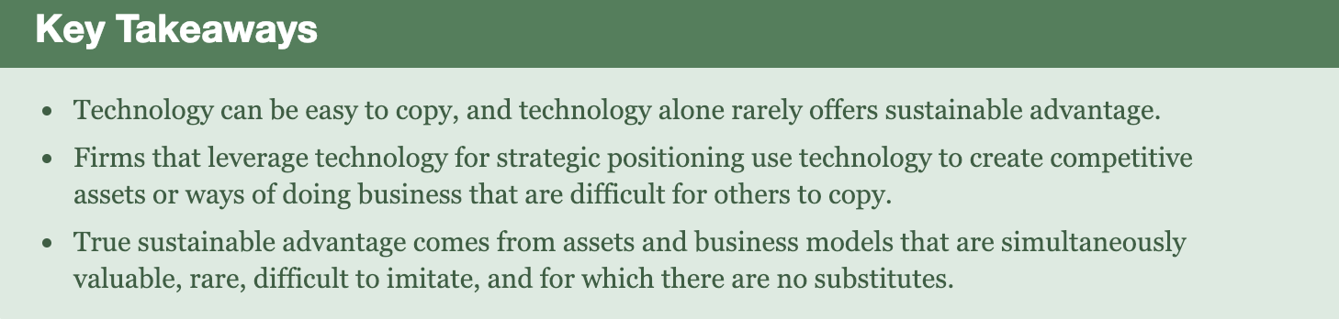

2.2 Powerful Resources

1. Imitation-Resistant Value Chains
   1. Imitation-resistant value chain: a way of doing business that competitors struggle to replicate and involves technology in a key role
   2. **Value chain**: activities through which a product or service is created and delivered to customers. 5 primary and 4 supporting components
      1. Inbound logistics – getting needed materials and other inputs into firm from suppliers
      2. Operations – turning inputs into products/services
      3. Outbound logistics – delivering products/services to consumers, distribution centers, retailers, partners
      4. Marketing and sales – customer engagement, pricing, promotion, and transaction
      5. Support – service, maintenance, customer support
      6. Firm infrastructure – functions that support the whole firm, including general management, planning, IS, finance
      7. Human resource management – recruiting, hiring, training, development
      8. Technology/research and development – new product and process design
      9. Procurement – sourcing and purchasing functions
      10. Used to determine a firm’s differences – competitive advantages

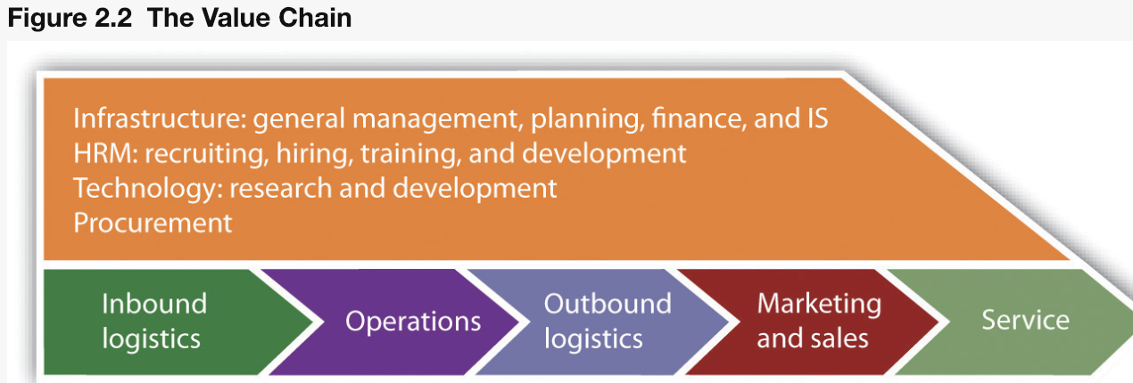

1. Dell’s Struggle
   1. Channel conflict: a firm’s potential partners see firm as a threat
   2. Sudden fell because raised laptop price
2. Brand
   1. Brand: symbolic embodiment of all information
   2. A strong brand proxies quality and inspires trust
   3. Viral marketing: use consumers to promote a product or service
   4. Branding help promote the brand so more people know it. But it is difficult, especially when competing with well-known brands
3. Scale
   1. Scale advantage: advantages related to size
   2. Economies of scale: when costs can be spread across increasing units of production or in serving a growing customer base. Firms benefit from scale economies are highly scalable
   3. Blue Nile
   4. Growing firms have bargaining powers with its suppliers/buyers. i.e. Apple can bargain with suppliers for importing screens at lower price
4. Switching Cost and Data
   1. Switching cost: the cost costumer pays when moving from one product to another
      1. Learning costs: learn new interface/commands
      2. Information and data: reenter data, convert files, might lose earlier contributions
      3. Financial commitment: new equipment, software, and devaluation of earlier investment
      4. Contractual commitments: breaking contracts lead to compensatory damages and harm reputation
      5. Search costs: finding new alternatives cost time/money
      6. Loyalty programs: costumer lose program benefits
   2. The harsh costs make users don’t want to switch; firms use this to keep costumers
   3. Need to persuade costumer the offering provides more value than current plus switching costs
   4. Data is a strong switching cost
5. Differentiation
   1. Commodities: products/service nearly identical offered from many vendors
   2. Firms use tech to differentiate themselves from others
6. Network Effects
   1. Network effects: Metcalfe’s law or network externalities. When value of a product/service increases as its number of users expand. Product become more valuable as more people use it
   2. Third-party attracted to bigger networks, making the product more valuable
7. Distribution Channels
   1. Distribution channels: the path a product/service get to customers (ex. Apple store)
   2. APIs (application programming interfaces): programming hooks that allow other firms to tap into their services
   3. Affiliates: third parties that promote a product/service in exchange for money
   4. Shouldn’t only depend on distribution channels by other firms
   5. Distribute products by bundling them with other offerings
8. What About Patents?
   1. Protects intellectual properties (technology)
   2. Non-Practicing Entities: patent trolls; make money by acquiring patents
   3. Patents confusing/blurred in software

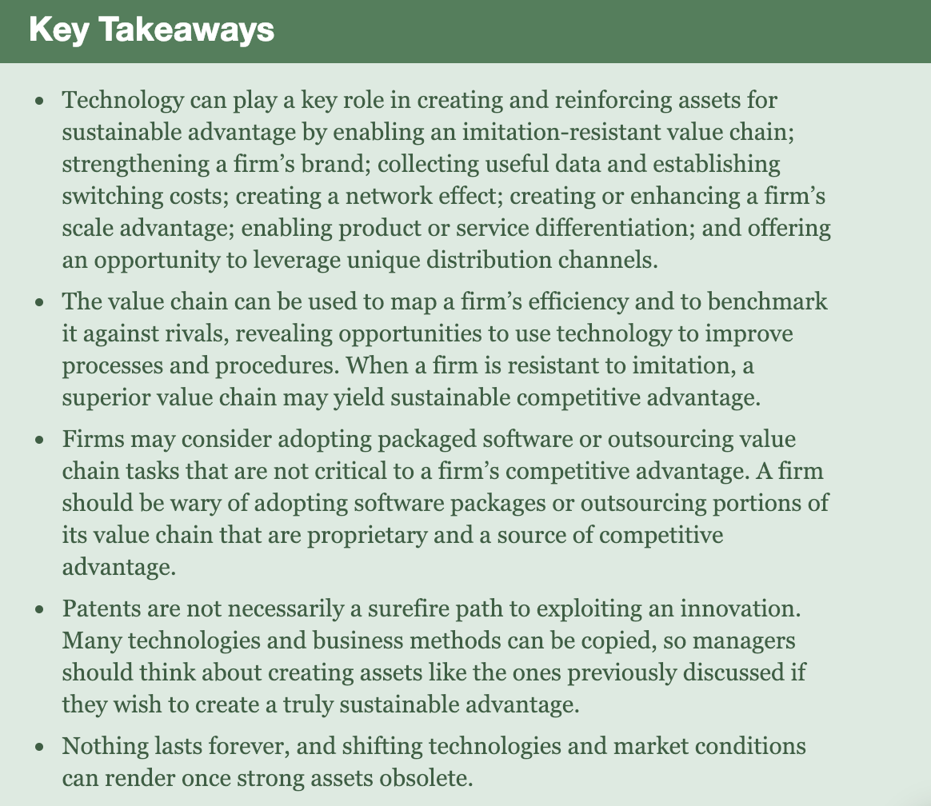

2.3 Barriers to Entry, Technology, and Timing

1. Internet > offline firms
2. What firms do with technology and time lead can make competitive advantages
3. True strategic positioning means firms created differences that cannot be matched by rivals
4. Most technology can be copied, but the lead can make firm successful
5. Current firms should pay attention to newbies for potential rivals

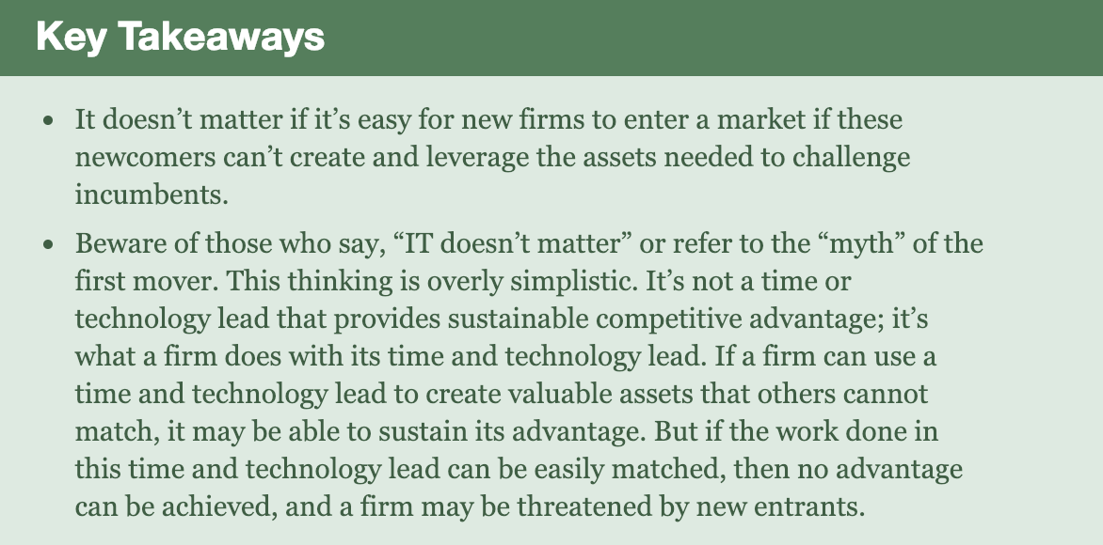

2.4 Key Framework: The Five Forces of Industry Competitive Advantage

1. **Porter’s five forces**: intensity of rivalry among existing competitors, threat to new entrants, threat of substitute goods/services, bargaining power of buyers, bargaining power of suppliers
2. Tech bring constant changes to these five forces
3. Price transparency: degree to which complete information is available
4. Information asymmetry: a decision situation where one party has more/better info than its counterparty

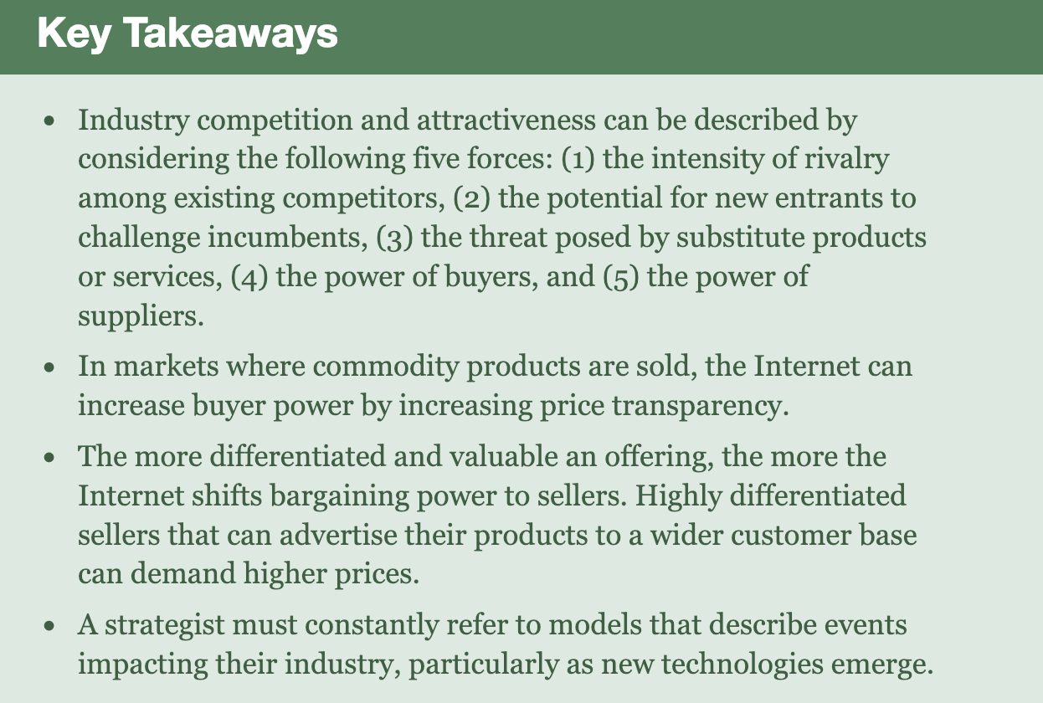

3.1 Zara Introduction

* Zara growing fast, making a lot of profit, high quality with cheap price, uses technology

1. Gap: An Icon in Crisis
   1. Retailers need to guess what customers want months in advance to order
   2. Inventory = death
   3. Contract Manufacturing: outsourcing production to third-party firms. Firms Don’t own plants or directly employ workers who produce goods -> Firms sell for cheaper price/more product -> Profit!
      1. Bad stuff like child workers in China
   4. Reebok created nonprofit Fair Factories Clearinghouse to track all suppliers on labor/safety…, so industries can share information on manufacturers

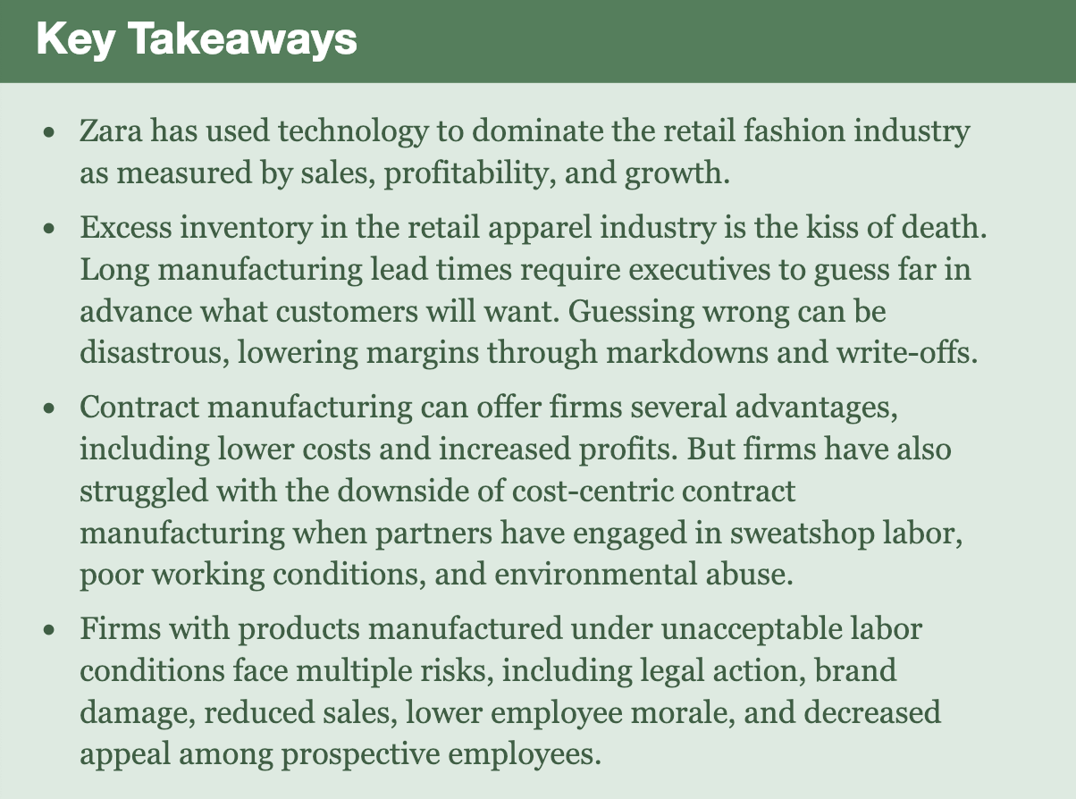

3.2 Don’t guess, Gather Data – Make Small Batches of What Customer Want and Ship it Fast!

1. Zara asks customers what they want and record online. Also look through piles of clothing to see trends
2. Point-of-sale (POS) System: transaction system that captures customer’s purchases. EX: cash register/store checkout. Important to gather sales data.
   1. Tells firm what’s selling
   2. PDA: tells what customers at a given location want to buy
   3. Allow firm to plan based on feedbacks rather than guesswork
3. Design
   1. What customer want -> then design it
   2. Big on teamwork
4. Manufacturing and Logistics
   1. Getting targeted designs quickly onto store shelves to avoid product going out of favor in the months to manufacture it
   2. 15 days for Zara to go from idea to appearance in store
   3. Zara has Vertical Integration: single firm owns all layers of its value chain
   4. Value chain: activities through which a product/service is created/delivered to customers
   5. Greige: goods to be customized based on designer/manager collaboration
   6. Zara uses close contract manufacturers
   7. Zara uses RFID effectively: small chip tags that wirelessly emit a unique identifying code for the item, to know where an item is
   8. Fast transportation
   9. Logistics: coordinating/enabling the flow of goods, people, info, and other resources
5. Stores
   1. Each Zara store has different clothing based on local customer taste
   2. Limited runs good: allow firm to cultivate exclusive offerings (have more variety of clothing), encourage customers to buy fast at full price, minimize risk to make mistake
   3. Flexible work hours based on customer rate
6. Integrating E-Commerce: Omnichannel = More Sales + Better Customer Experience
   1. Omnichannel: offer customer an integrated/complementary set of shop, sales, and return experience (online & offline)
   2. Online shopping fluid with offline shopping
   3. Zara doesn’t have a lot of IT compared to other stores
   4. Prada’s instore technology was too much/too fancy
   5. 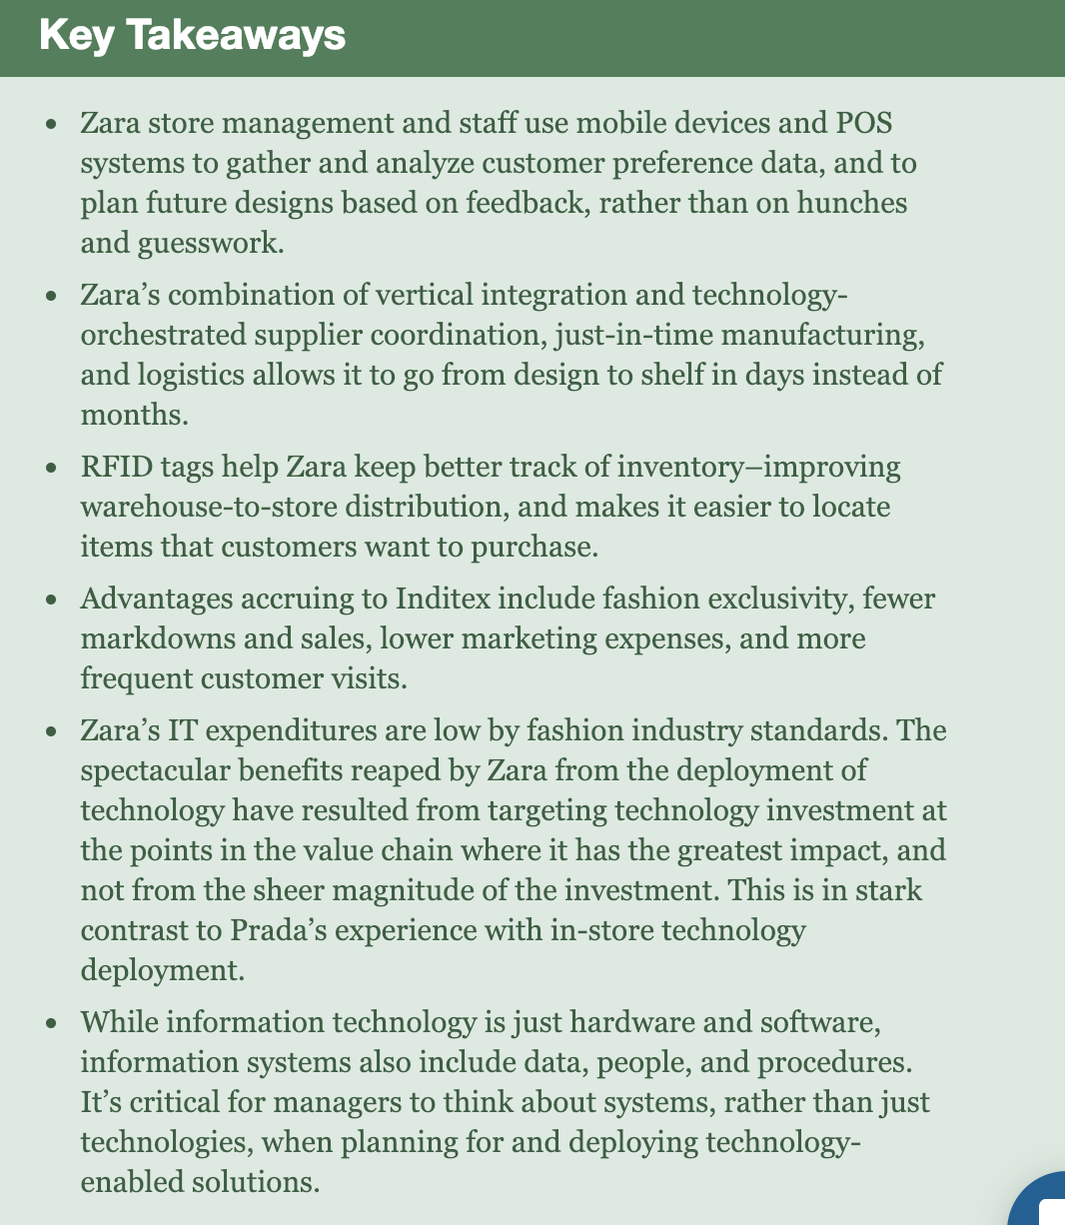Return on Investment (ROI): amount earned from an expenditure

3.3 Moving Forward

* Zara also faces challenges
  + Only 2 locations firm deliveries, if something goes wrong, nothing to fall back on
  + New logistic center in Asia
  + Showrooming: customer browse at physical retailers, but buy products from lower-cost online rival

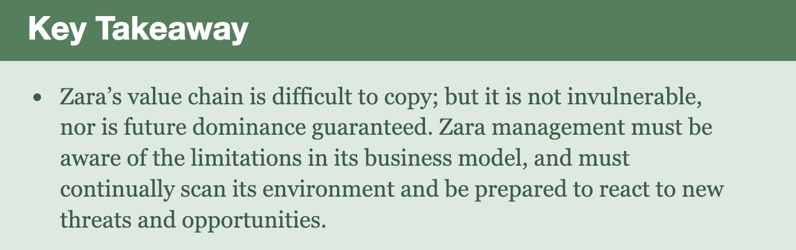

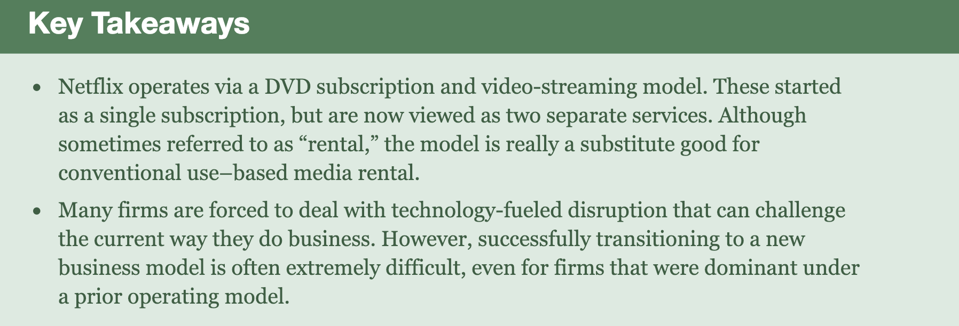4.1 Introduction

4.2 Act I: David Becomes Goliath: Crafting killer Assets for DVD-by-Mail Dominance

1. Netflix created brand, scale, and a data asset that rivals could not match
2. Brand Strength from Best-in-Class Customer Experience
   1. Brands are built through customer experience
   2. Advertising only build awareness
   3. Netflix was ranked best in good customer experience – (top of the American Customer Satisfaction Index and Nielsen ranking; named by ForeSee as the #1 e-commerce site)
3. Scale from the Distribution Network
   1. Netflix had a giant scale, weakening rival’s brands
   2. A nationwide network of 58 distribution centers that can deliver DVDs overnight to 97% of the US pop
4. Scale from Selection: The Long Tail
   1. Netflix had limitless selection of DVDs -> customer had more choices
   2. Long tail: extremely large selection of content/products. Firms can make money by offering a near-limitless selection
   3. 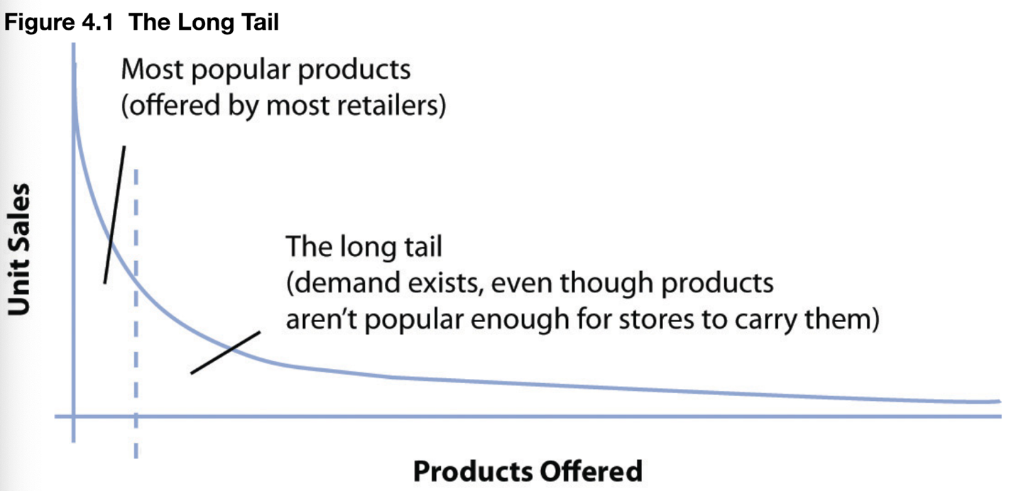Selection attracts customers, internet allows large-selection inventory efficiencies that offline firms can’t match
5. The Big Customer Base – Delivering True Economies of Scale
   1. Netflix had bigger customer base, so they get more money and profit
   2. Since the cost to run the company is the same, companies with more customer (thus more profit) has better advantage
6. Leveraging the Data Asset: Collaborative Filtering and Beyond
   1. Collaborative filtering: software that monitors trends among customers and use this data to personalize an individual customer’s experience
   2. Netflix uses Cinematch to customize webpages to fit user’s preference and give recommendations
   3. This is also a switching cost – if user switch to another viewing company, they abandon all their previous ratings and recommendations
   4. Churn rate: rate at which customers leave a product/service
   5. Although Blockbuster and Walmart launched similar recommendation service, less users left Netflix because they want to keep their data
   6. Make studios happy by using Cinematch to help them find audiences for back catalog titles
7. Winning Act I
   1. Largest selection, largest network of distribution centers, largest customer base, strength in brand and data assets

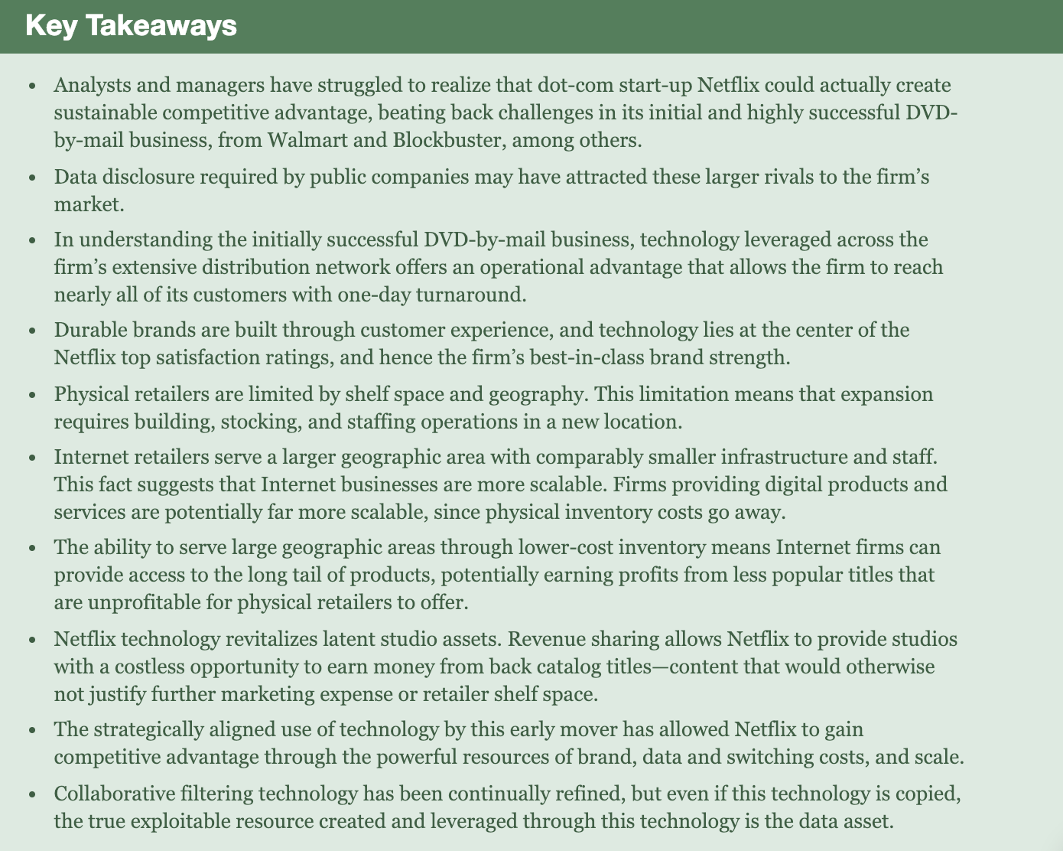

4.3 Act II: Netflix and the Shift from Mailing Atoms to Streaming Bits

1. Atoms to Bits
   1. Media are all digital now
2. The Qwikster Debacle
   1. Netflix tries to move to internet streaming with the new Qwikster and increased their price, this caused very heavy customer backlash
3. Digital Products and Marginal Costs
   1. Fixed cost: costs that do not vary according to production volume
   2. Marginal costs: costs associated with each additional unit produced
   3. Digital goods also have margin costs: fee to telecommunication providers, servers, license fees
   4. Coopetition/Frenemies: firms may both cooperate and compete with one another
4. Content Acquisition: Escalating Costs, Limited Availability, and ‘Long-Enough Tail’
   1. Netflix needed separate streaming licenses to offer Internet streaming, but these license costs are very expensive
   2. Only a few firms control all US media. Also, video contents are differentiated = providers have more bargaining power. Also a lot more competitors but same numbers of providers, so prices are very high for Netflix to buy videos from the firms.
   3. Windowing: making content available for a specified time window
   4. Streaming license make it hard for companies to plan and estimate costs
   5. Some firms refuse to offer Netflix streaming rights
   6. If firms rely on one channel partner, the partner have the advantage in negotiations
5. Exclusives and Original Content
   1. Netflix have its own exclusive content
   2. Netflix have original content that win awards and viewer’s heart
   3. Although making these original contents cost a lot of money, Netflix’s increasing costumer subscription make these worth it
   4. Netflix’s first few originals are licensed by other studios, so they are not exclusive, but they are planning to have complete ownership of new projects
6. Streaming and the Data Asset
   1. Netflix has BIG customer database
   2. Even if user doesn’t rate, Netflix knows what their opinions on the show are with internet
   3. Netflix analyzes terabytes of data to provide recommendation to users. This is a big success because most users use recommendation instead of searching for a film, making huge profits for Netflix
   4. A/B Test: A randomized group of experiments used to collect data and compare performance among two options. Used in refining technology designs.
   5. Netflix uses data to set budges and decide renewals
   6. Uses data to determine which viewer see what type of trailer for the same movie
7. Streaming Changes Viewing Habits and Frees Creative Constraints
   1. Streaming allows viewers to watch multiple episodes at once so they don’t forget characters/lose interest
8. Customer Experience, Complexity, Pricing, and Brand Strength
   1. All of its content available anywhere for a single monthly fee (without the weird extra fees)
9. Streaming and Scale Advantages
   1. Cycle: more titles attract more customers -> more customer more profit -> more profit keep more good content
   2. Large scale to keep competitors at bay
   3. Can spend more money too
10. The March to Global Dominance
    1. Netflix’s service available in over 190 countries
    2. Difficulties with laws, money, but still profited
11. It’s a Multiscreen World: Getting to Netflix Everywhere
    1. Netflix not only launch its service on PCs, but on TVs as well with software
    2. Netflix difficult to be offered through cable provider’s set-top box
12. So What’s it take to Run This Thing?
    1. Netflix uses Amazon’s cloud efficiently
    2. Netflix likes to share its code to everyone – more people use it more people improve it
13. Crowdsourcing and Code Contests: The Netflix Prize and Beyond
    1. Crowdsourcing: let the community to solve the problem
    2. Benefits the company to solve problems and have good public relations
14. A Crowded Field of Rivals and Other Challenges
    1. Although small firms cannot threaten Netflix, bigger firms are willing to spend more and endure mid-losses
    2. Susceptible to online reliability issues
    3. Stricker ISP rules on bandwidth traffic
15. Hacking Corporate Culture
    1. Netflix give employees many benefit: vacation time, good pay,

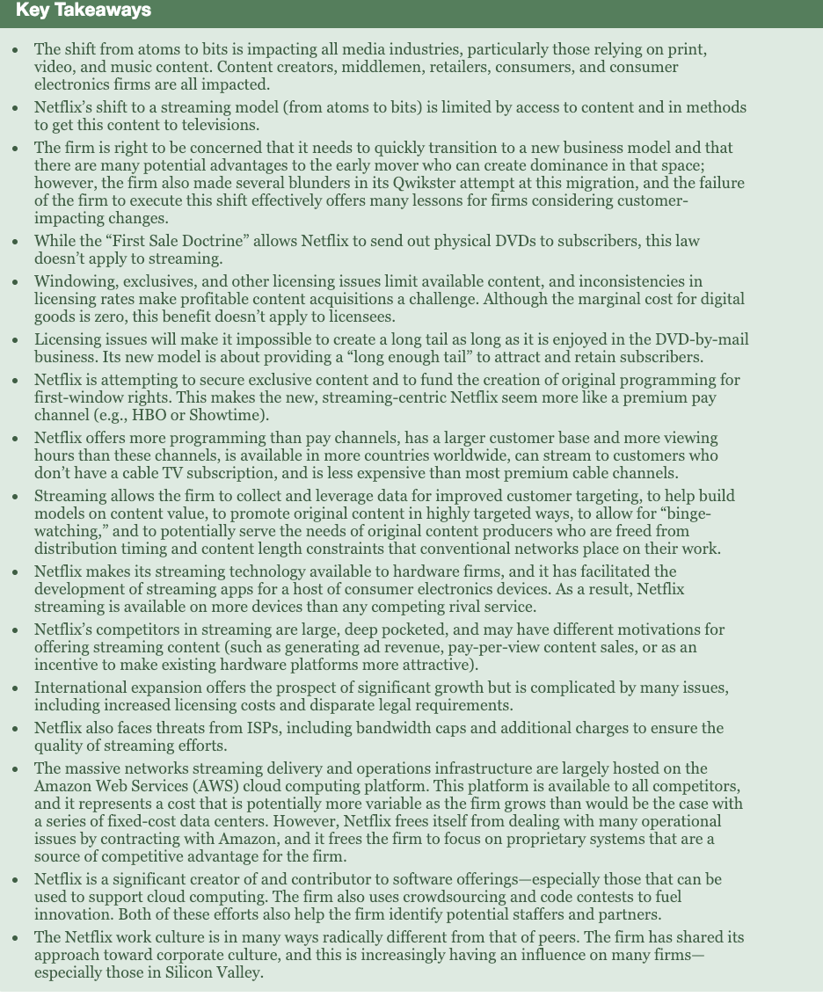

# Chapter 5: Moore's Law and More: Fast, Cheap Computing, and What This Means for the Manager

5.1 Introduction

1. Moore’s Law
   1. “faster, cheaper” semiconductor industry
   2. Chip performance per dollar doubles every eighteen months – advances in chip making make more powerful chips at cheaper prices
   3. Microprocessor: part of computer that executes instructions of programs
      1. 2x fast in 18 months but cost the same as today
   4. Random-access memory (RAM): volatile memory – memory cleared when powered off
      1. Temporary storage with fast access
   5. Non-Volatile Memory: retains data even when powered down (flash drive, hard disks)
   6. Flash memory: non-volatile, fast, solid state electronics (semiconductor-based, suffer fewer failures and require less energy, no moving parts)
      1. 2x storage in 18 month but cost same as today
   7. Moore’s law does not apply to other technologies, but others are also trying to be cheap and better – massive improvement over time
2. Get Out Your Crystal Ball
   1. Price Elasticity: the rate at which the demand for a product fluctuates with price change
   2. Technology are highly price elastic – consumer buy more when it’s cheaper
   3. Evolving waves of computing: 1. Large room-sized computers 2. Refrigerator sized computers (Moore’s Law invented) 3. PCs 4. Internet computing 5. Mobile phones 6. Pervasive computing (technology is cheap and fast and everywhere)
   4. Sony didn’t follow Moore’s Law and died – Moore’s Law good
   5. Optical Fiber grows fastest(double 9 months)

Data Storage grows second (doubles 12 months)

Moore’s Law grows Last (doubles 18 months)

* 1. If producing products subject to radical improvement, these product’s values will fall fast over time – overproducing these is deadly

1. Tech Everywhere: From the Smart Thermostat to a Tweeting Diaper
   1. Nest – saves energy and bills
   2. Fast, cheap computing
   3. Internet of Things: a vision where low-cost sensors, computing, and communication are embedded in all devices so these products can communicate for data collection – where everything is smart
2. Moore’s Law Inside Medicine Cabinet…and Colon
   1. GlowCap flashes when you should take your medicine, send report to your doctor, and send refill notification to pharmacy
   2. Costs $10 sometimes for free to increase medical adherence
   3. Proteus is digestible pill, it reports your body stats and even take pictures

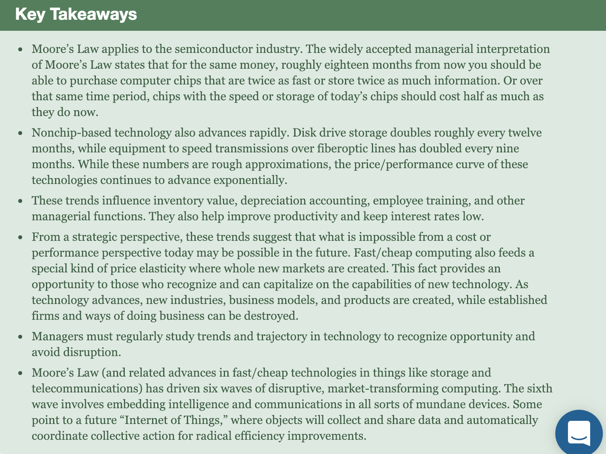

5.2 The Death of Moore’s Law?

* Moore’s Law is not scientific – it states we are getting better at squeezing more stuff into tinier pieces
* Only possible bc distance between pathways in silicon chips gets smaller each generation –> shorter distance for electrons to travel -> twice as fast
* Size, Heat, and Power threatens Moore’s Law
  + Smaller processor -> tightly packed electrons -> more heat needs fans -> costly to cool
  + Chips cannot get smaller forever
  + Death of Moore’s Law is soon
* Multicore microprocessor: microprocessor with 2+ processor cores
  + Cooler, less power than single chip
  + Smaller portion of problem executed in each core
  + Very hard to code for but good for video games
* Use chips designed to be really good at something
  + ASIC: chips designed to be really at a specific task
  + FPGA: chips that can be programmed after purchase to reroute pathways for application-specific efficiency

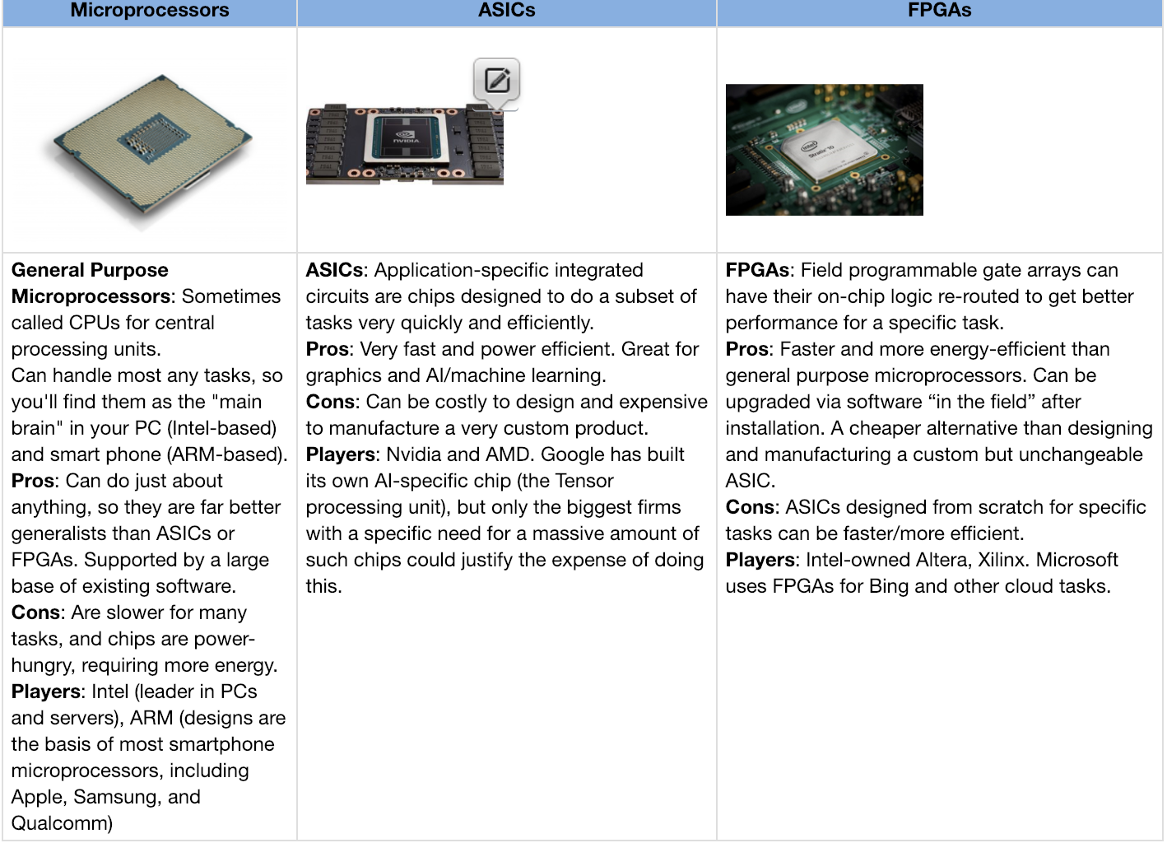

* Trying to save Moore’s Law: from 2D chips to 3D
* Quantum computing: uses qubits that can be both 1 and 0 at same time. Capacity increases exponentially

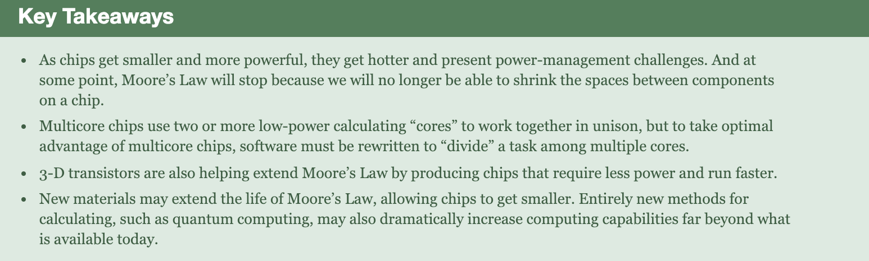

## 5.3 The Power of Parallel: Supercomputing, Grids, Clusters, and Putting Smarts in the Cloud

1. Supercomputers: computers that are among the fastest of any in the world at the time of their introduction
2. Supercomputers were used for government and research lab, but with tweaking, it can be used in business”
   1. Massively parallel: computers designed with many microprocessors (found in BestBuy) that work together – have several chips in one computer
   2. Watson
3. Grid computer: use special software to enable several computers to work together on a common problem like a parallel supercomputer
   1. Attack portion of a complex task
   2. Use existent computers to work on a single task
4. Cluster computing: connecting server computers via software and networking so their resources can be used to collectively solve computing tasks
   1. Use existent computers to work on a single task – tightly coupled with additional software
5. Multicore: having several processors in a single chip
6. Restrictions: software need to divide problems into smaller pieces to be handled respectively
   1. Simulations are easy, but linear problems(need one step to do second step) are hard to split
7. Software as a service (SaaS): a firm use a third-party software and receives a service that is delivered online
8. Cloud computing: replace computing resources with services provided over internet
   1. Slower and less reliable
   2. Latency: delay
9. Abandon traditional soft/hardware that would run in-house with service delivered online
10. Serve farms: a network of computer servers running software to coordinate their collective use – Saas and cloud
    1. Bring large computing power to little org

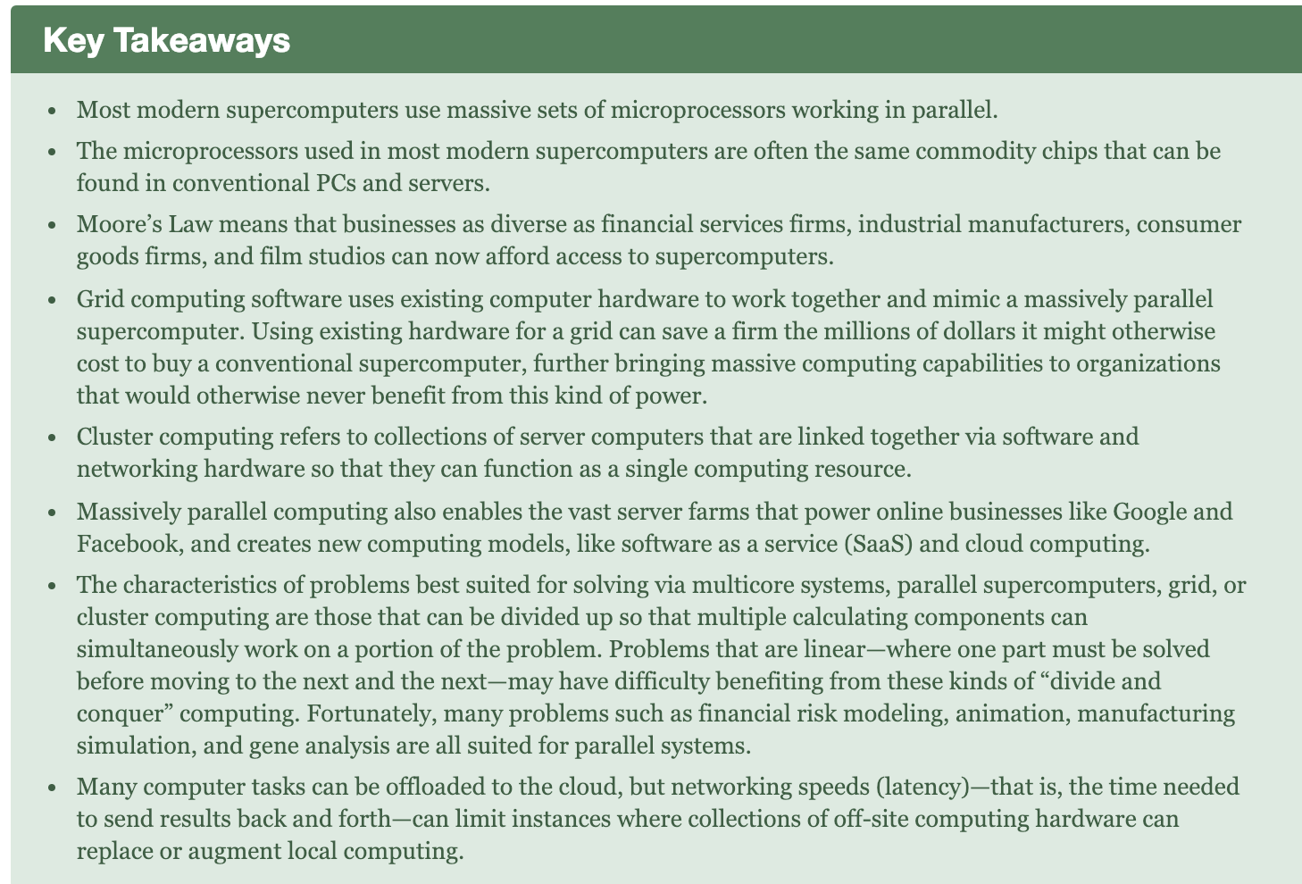

5.4 E-Waster: The Dark Side of Moore’s Law

1. Rapid growth -> more e-waste
2. Difficult to address problem of recycling e-waste
   1. Although recycle is cheaper & greener
   2. Labor intensive – most e-waste exported
   3. Very harmful for humans & environments
   4. People export e-waste illegally
3. Big firms are targeted to be green by environmentalists
   1. Firms must plan for the waste
   2. Must examine recycling partner with vigor
4. Moore supports environmental issues

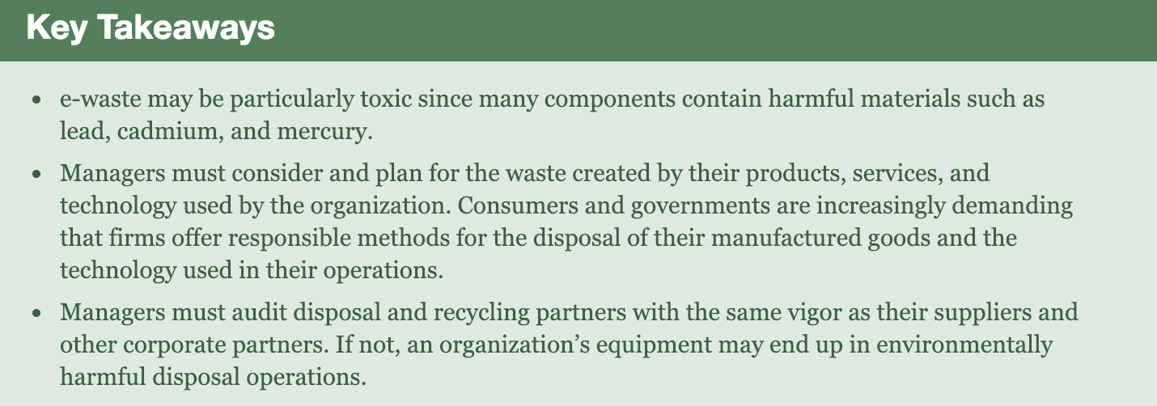

5.5 Mickey’s Wearable: Disney’s Magic Band

1. MagicBand used for everything in Disney
   1. Privary concerns – data anonymized and encrypted
2. Experience Examples
   1. Turn waiting time to interactive experience
   2. Be our guest restaurant
3. Big Data and Big Benefits
   1. Delight + efficiency
   2. Guests don’t have to walk through park to find rides
   3. Use data to craft a custom guest itinerary
      1. Big data analytics and efficient scheduling algorithms
   4. When to add more staff, stock restaurants…
4. Magical Experiences Cost Serious Coin
   1. Expensive system + educating staff
   2. Marginal cost: band more expensive than tickets
5. Magical experiences require Magical Coordination
   1. Needed Disney IT team, third-party companies to make this all possible – disputes/conflicts inevitable
   2. But strong leadership helped
6. Look to the Future
   1. Variations on MyMagic roll out to Disneyland worldwide
   2. Bar-setting innovation have influence on customer expectations

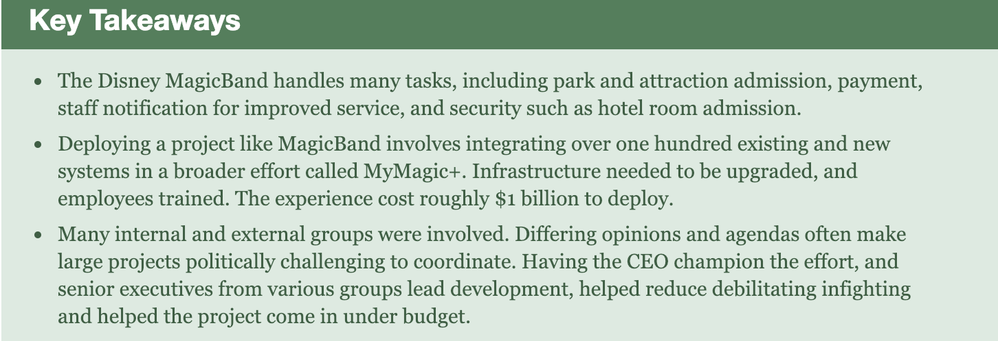

# Chapter 6 Disruptive Technologies: Understanding Giant Killers and Tactics to Avoid Extinction

6.1 Introduction

1. The Characteristics of Disruptive Technologies
   1. Come to market with set of performance attributes that existing customers don’t value
   2. Over time, the performance attributes improve so they invade established markets
   3. Technologies that didn’t seem important at first, but grew so quickly
2. Why Big Firms Fail
   1. Big firms fail to see disruptive innovations as threat bc they listen to customer and focus on bottom line
   2. Majority of firm’s customers don’t want the initial-bad-performing tech – so firms don’t spend money developing
   3. Customers for disruptive tech are a different “value network” than incumbent customer – but incumbent customer get convinced to disruptive tech
   4. By the time disruptive are everywhere, startup companies have developed expertise in them, and big firms have to try to catch up
3. Don’t Fly Blind: Improve Your Radar
   1. Firms should pay attention to trajectory of fast/cheap tech advancement and new/emerging tech
   2. Remove customer-focused shortsightedness
   3. Communication between managers and technologists
   4. Pay attention to employees who leave their company to develop new tech
4. Potential Disrupter Spotted: Now What?
   1. Transition from currently popular project to work on a project with no popularity and future can cause lower profits
   2. Firms build portfolio of emerging technologies to focus on the next big thing
   3. Have staff work on innovation aside from core business
   4. Hard to do/predict in reality

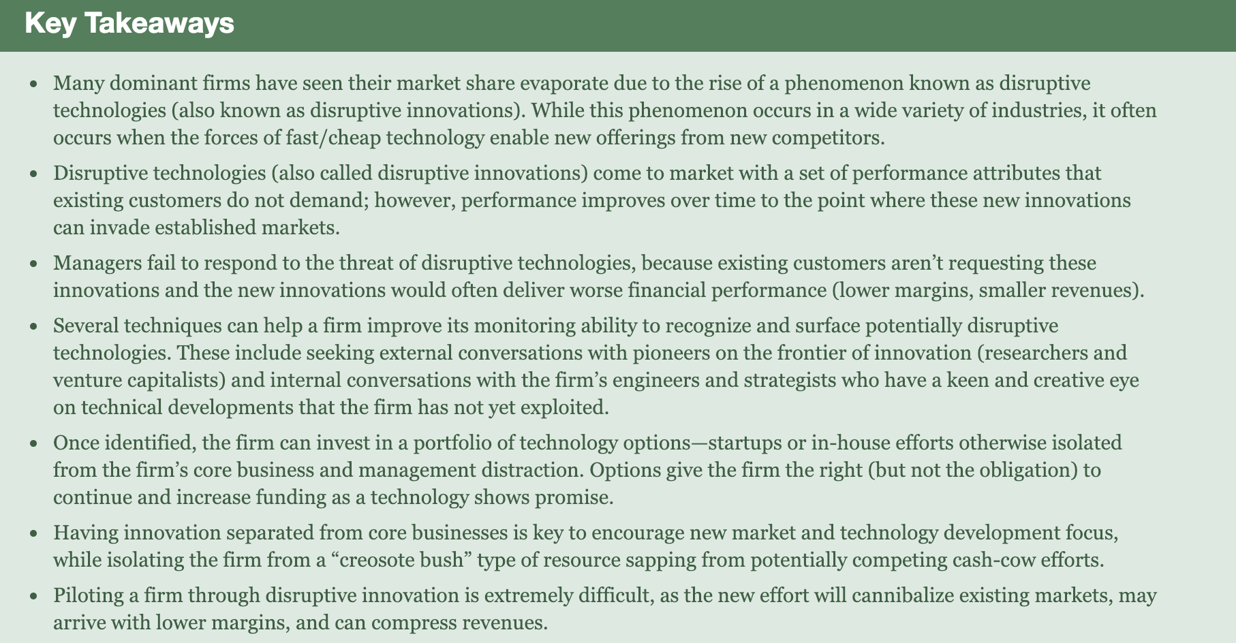

6.2 From Bitcoin to Blockchain and Beyond: A Disruptive Innovation for Money and More

1. Bitcoin: open source, decentralized payment system that operate in a P2P environment without bank
   1. Favored by cybercriminals
   2. Widely volatile
   3. Created by miners (using math)
2. Cryptocurrencies: math used to handle transactions, control creation…take advantage of blockchain
3. Blockchain: decentralized ledger that records/verifies transactions and ownership, hard to temper with or shut down
   1. Transparent transaction – can trace product’s path
   2. Shared form of record keeping
4. How it Works
   1. No physical representation – exist online
   2. P2p
   3. Verification performed by miners
   4. Need password (private key) to transfer
5. Benefits
   1. P2P – cuts out transaction fees
   2. Boon for international commerce, bad for cross-border remittance and expanding e-commerce in emerging markets
      1. Very easy to transfer internationally
   3. Transparent(all transactions recorded) and private(are anonymous)
   4. No single controlling entity where fraud, hacking, shutdown can occur
   5. Blockchain is better, cheaper, faster, more secure
      1. A standard for securely exchanging value and recording ownership over a network without an intermediary
6. Concerns
   1. Customer benefit needs to be stronger
      1. Cryptocurrency difficult to understand and use and offer little benefits
   2. Reputable problem – drug dealers, bitcoin created by unknown called Satoshi Nakamoto
   3. Security Concerns – hackers steal passwords
   4. Firms struggle under ambiguous cloud of not knowing how they will be regulated
   5. Volatility – value fluctuates wildly, make bitcoin less useful
   6. Increased transaction volume should help stabilize market
      1. A lot more transactions means bitcoin need more infrastructure support
      2. Trouble handling transaction volume
         1. Scalability problem – too small

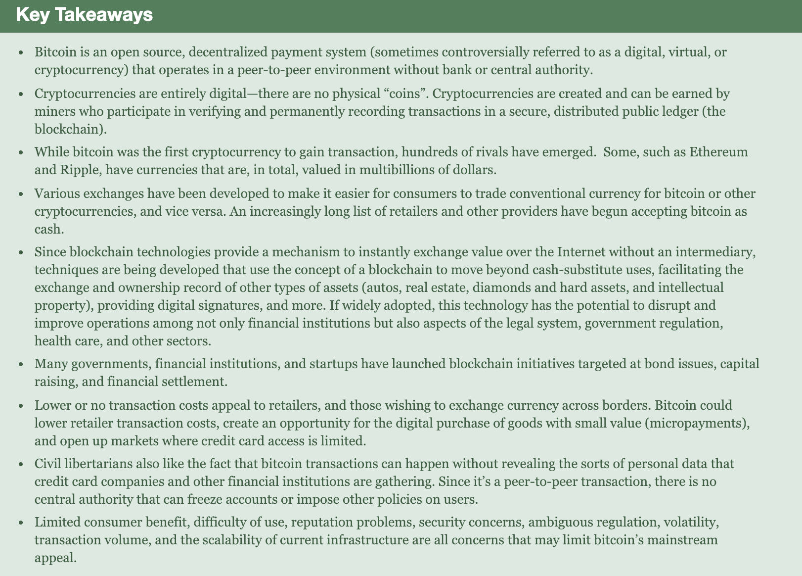

Chap 7

7.1

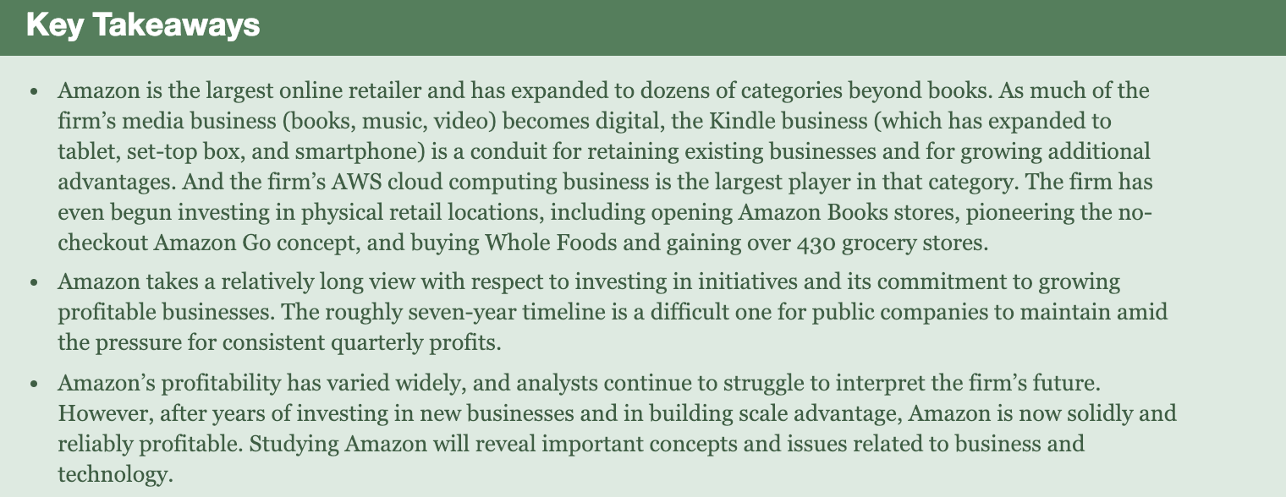

7.2 the emperor of e-commerce

1. Three pillars of Amazon’s business: large selection, customer experience (brand, scale), lower prices (vertical integration)
2. Buyer-seller growth = network effect
3. Fulfillment operation – driving selection, customer convenience, and low price
   1. Instead of getting large amount of same product, Amazon packs smaller boxes of different item
   2. Coordinate technology, robots, and human workers
      1. Use Kiva robots to stock shelves – less error, more efficient/fast, hire more employees, but costly
      2. Short human contact
      3. SLAM(scan, label, apply, manifest) – use robots/tech with minimum human help, helped fulfill same-day delivery, v fast
4. Amazon’s Cash Conversion Cycle – Realizing Financial Benefits from Speed
   1. Account payable:money owed for product purchased on credit
      1. Big firms buy w/ credit and can paly later
   2. Cash conversion cycle: period between distributing cash and collecting funds
      1. Costumer pay right away
   3. Liquidity problem: org cannot convert asset to cash (cash is most liquid bc it is widely acceptable)
      1. Amazon has negative CCC – sell to customer before paying its supplier
   4. Inventory turns: number of times inventory is sold
   5. Amazon advantage: Negative cash conversion cycle
5. Internet economics, scale, pricing power
   1. Selling more goods -> amazon has bargaining power with suppler and bigger scale
6. The advantage of Being Big: Realizing Scale Advantages as the Retail e-Commerce Leader
   1. Amazon price cheap
   2. Bigger scale to overthrow small competitors
   3. Dynamic pricing: pricing that shifts over time based on change of demand

Chap 8: Network

8.1 Intro

1. Network effects: Metcalfe’s Law.network externalities. When the value of a product increases as its number of users expand
2. Rocket fuel for tech firms – build big user bases
3. When network effects are present, *the value of a product or service increases as the number of users grows*
4. More users = more value
5. Among the most important reason you will ick one product over another
6. Platform: products that allow for development and integration of software and other complementary goods -> create an ecosystem of value-adding offerings

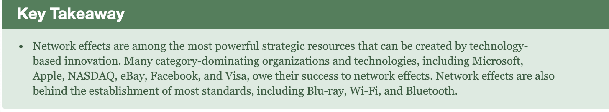

## 8.2 Platforms Are Powerful, But Where Does All That Value Come From?

1. Exchange
   1. Network effects foster exchange
   2. Attract more users
2. Staying Power
   1. Network with more users have stronger staying power
      1. Staying power: long-term viability of a product
      2. Stay longer, more switching cost
3. Complementary benefits
   1. Complementary benefits: products that add additional value to network
      1. Add-ons like software
4. Exchange, staying power, and complementary benefits make network effects stronger

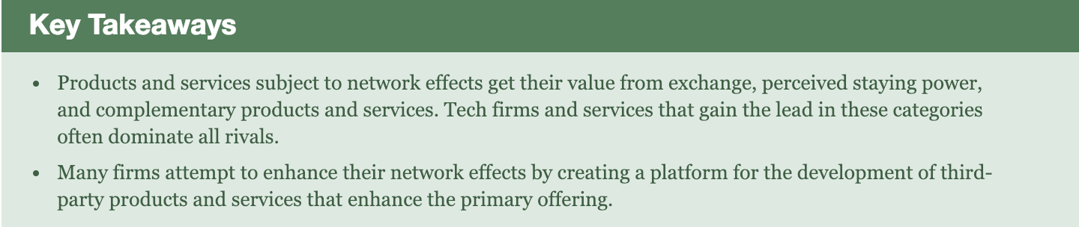

## 8.3 One-Sided or Two-Sided Markets?

1. Understand Network Structure
   1. One-sided market: a market that derives value from a single class of users ex messaging
   2. Same-side exchange benefits: benefits derived from interaction among members of a single class of participants
   3. Two-sided market: network market with 2 categories of participants and both are needed (video game console owners and developers of video games)
   4. Cross-side exchange benefit: hen an increase in the number of users on one side of the market (console owners, for example) creates a rise in the other side (software developers)

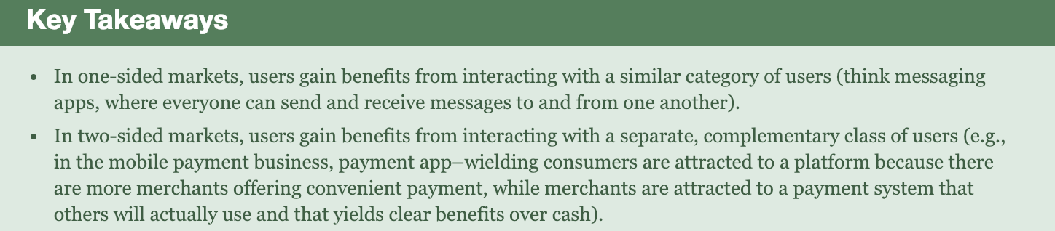

8.4 How Are These Markets Different?

1. Network markets experience early, fierce competition
   1. Because once a leader is formed, everyone goes to that leader, tipping market in favor of one dominance
2. Positive feed-back loop – big network becomes bigger
3. Exhibiting monopolistic tendencies
   1. One firm dominates all rivals
4. Oligopoly: a market dominated by a small number of powerful sellers
5. Best product don’t always win
6. Technological leapfrogging: competing by offering a superior generation of technology
   1. Very hard
   2. Hard for newcomer to attack an established rival
   3. Need to new and hard-to-copy innovations
7. IS THIS GOOD FOR INNOVATION
   1. Network effects limit competition against the dominant standard, but innovation within a standard may blossom
      1. Competitors against windows is limited
      2. Programmer write software for windows
   2. Multiple forms of smartphones – hard for developers to write apps
      1. Apple came along, the developers can write for the huge market with consistency

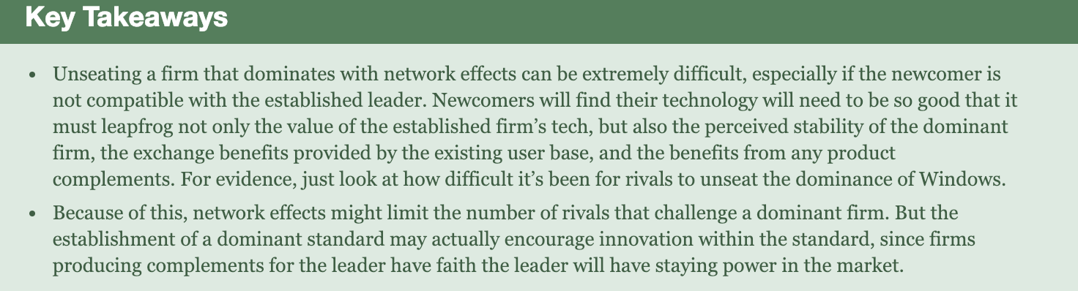

8.5 Competing When Network Effects Matter

1. Move Early
   1. Being first allow the firm’s network effect to snowball – good!
2. Subsidize adoption
   1. Include price reduction, rebate, giveaways
   2. Doesn’t always work – when switching cost is high
3. Leverage Viral Promotion
   1. Use a firm’s customers to promote product
   2. Relate to subsidize – let friends send invites and get discounts
4. Expand by redefining the Market
   1. Define space to bring in more uses
   2. Nintendo not only appealed to male-gamers, it appealed to families, women…
   3. Blue ocean strategy An approach where firms seek to create and compete in uncontested “blue ocean” market spaces, rather than competing in spaces and ways that have attracted many, similar rivals.
   4. Convergence: two markets, once separate, begin to have similar features
   5. Envelopment: a firm seeks to make an existing market a subset of its product offering
5. Alliances and Partnership
   1. Firms partner up together to take down a big rival
6. Leverage distribution Channels
   1. New ways to distribute product
   2. Create distribution channels
   3. Bundle new products with other existing products
      1. Some places don’t like this like Europe and requires unbundle
7. Seed the Market
   1. Decreasing prices by a lot
   2. Give away products for free for two-sided market
8. Encourage the development of complementary goods
   1. Make other make complementary goods for your network
      1. Developer subsidy/ discounted service
      2. Free software development kit, training programs
   2. Amazon has a $100 million fund to developers enhancing technologies and providing new apps (called “skills” by Amazon) for its voice-activated Echo products.
9. Leverage Backward Compatibility
   1. Backward compatibility: take advantage of complementary products for a prior generation of technology
   2. If they not lose advantage of switching cost of prior customers
   3. Adapter: A product that allows a firm to tap into the complementary products, data, or user base of another product or service.
10. Rivals: Be compatible with the leading network
    1. Make new products compatible with leading standard
11. Incumbents: Close off rival access and constantly innovate
    1. Dominant firms make compatibility difficult for rivals who want to connect with their system
    2. Firms that constantly innovate make it particular difficult for competitors to become compatible
12. Large, Well-known followers; Preannouncements
    1. Preannounce to cause potential adaptors waiting, to delay their purchasing decision until new products come out
    2. Only works for big firms that can pose a credible threat to current market participants
    3. Osborne effect: When a firm preannounces a forthcoming product or service and experiences a sharp and detrimental drop in sales of current offerings as users wait for the new item.
13. Sometimes service attract too many users and is overwhelmed
    1. Congestion effect: When increasing numbers of users lower the value of a product or service.

